HOODIE ORDER FORM

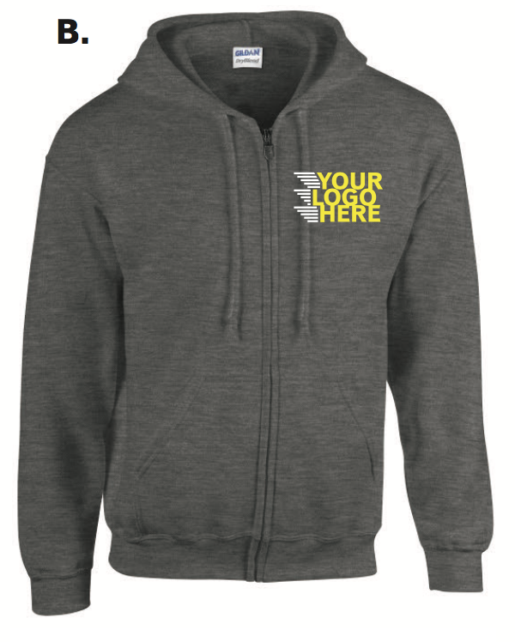
Name
Size (check one) | XS |  | $45
 | S |  | $45
 | M |  | $45
 | L |  | $45
 | XL |  | $45
 | XXL |  | $45
Grad year on sleeve (optional) | Yes |  | $6.50
 | No |  | $0
Grad Year

Nicole Slipp (Special Projects Chair) will be collecting order forms. Give her a printed form in person or email a digital copy to nicole.slipp@dal.ca. You can send payments to Brian Jenkins, our Financial Chair, by e-transfer at brian.m.jenkins@gmail.com.

DEADLINE TO RETURN FORM: JANUARY 31ST

